Assignment 10

**Problem Statement 1:**

**Scipy:**

We have the min and max temperatures in a city In India for each months of the year.

We would like to find a function to describe this and show it graphically, the dataset

given below.

Task:

1. fitting it to the periodic function

2. plot the fit

Data

Max = 39, 41, 43, 47, 49, 51, 45, 38, 37, 29, 27, 25

Min = 21, 23, 27, 28, 32, 35, 31, 28, 21, 19, 17, 18

Expected Output:

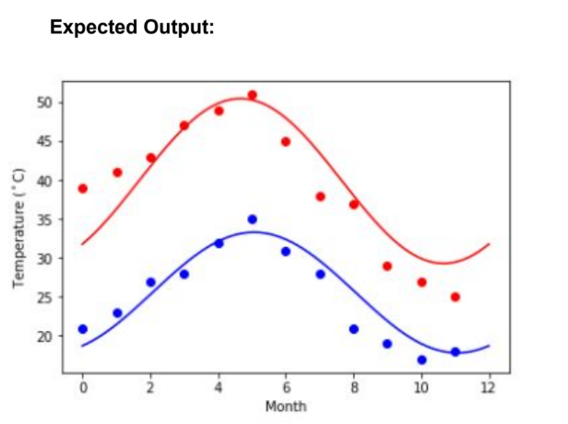

**Code:**

#The data

import numpy as np

temp_max = np.array([39, 41, 43, 47, 49, 51, 45, 38, 37, 29, 27, 25])

temp_min = np.array([21, 23, 27, 28, 32, 35, 31, 28, 21, 19, 17, 18])

import matplotlib.pyplot as plt

months = np.arange(12)

plt.plot(months, temp_max, 'ro')

plt.plot(months, temp_min, 'bo')

plt.xlabel('Month')

plt.ylabel('Min and max temperature')

#Fitting it to a periodic function

from scipy import optimize

def yearly_temps(times, avg, ampl, time_offset):

return (avg + ampl * np.cos((times + time_offset) * 2 * np.pi / times.max()))

res_max, cov_max = optimize.curve_fit(yearly_temps, months,

temp_max, [20, 10, 0])

res_min, cov_min = optimize.curve_fit(yearly_temps, months,

temp_min, [-40, 20, 0])

#Plotting the fit

days = np.linspace(0, 12, num=365)

plt.figure()

plt.plot(months, temp_max, 'ro')

plt.plot(days, yearly_temps(days, *res_max), 'r-')

plt.plot(months, temp_min, 'bo')

plt.plot(days, yearly_temps(days, *res_min), 'b-')

plt.xlabel('Month')

plt.ylabel('Temperature ($^\circ$C)')

plt.show()

**Screenshot:**

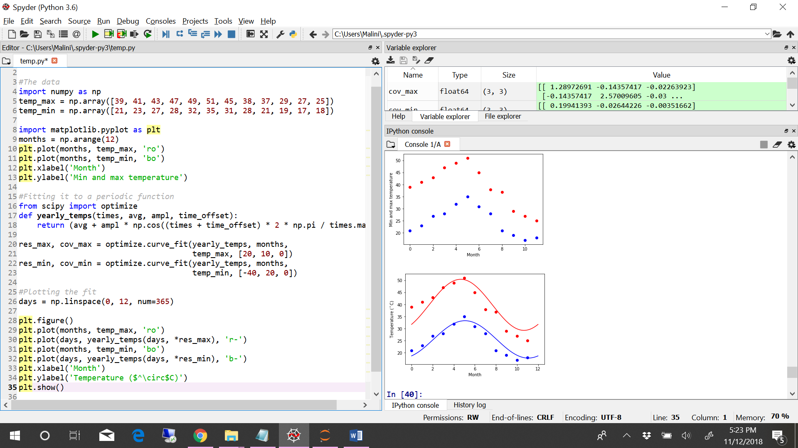

**Problem Statement 2:**

Matplotlib:

This assignment is for visualization using matplotlib:

data to use:

url=https://raw.githubusercontent.com/Geoyi/Cleaning-Titanic-Data/master/titanic_original.csv

titanic = pd.read_csv(url)

Charts to plot:

1. Create a pie chart presenting the male/female proportion

2. Create a scatterplot with the Fare paid and the Age, differ the plot color by gender

Code:

import pandas as pd

from matplotlib import pyplot as plt

#1.Create a pie chart presenting the male/female proportion

url='https://raw.githubusercontent.com/Geoyi/Cleaning-Titanic-Data/master/titanic_original.csv'

df = pd.read_csv(url)

gender_category = ['Male','Female']

no_of_males = len(df[df.sex == 'male'])

no_of_females = len(df[df.sex == 'female'])

proportion_of_male_female = [no_of_males,no_of_females]

colors = ["blue", "red"]

explode = (0.1, 0)

plt.pie(proportion_of_male_female, labels=gender_category, explode=explode, colors=colors,

autopct='%1.1f%%', shadow=True, startangle=90)

plt.title("Chart presenting the male/female proportion")

plt.show()

#2.Create a scatterplot with the Fare paid and the Age, differ the plot color by gender

plt.scatter(df[df.sex == 'male'].age, df[df.sex == 'male'].fare, label = 'Male', alpha=0.4, color = 'b')

plt.scatter(df[df.sex == 'female'].age, df[df.sex == 'female'].fare, label = 'Female', alpha=0.4, color = 'r')

plt.title('Fare Paid vs Age')

plt.xlabel('Age')

plt.ylabel('Fare')

plt.legend()

plt.show()

